

**University of Wollongong**

School of Computing and Information Technology

Faculty of Engineering & Information Sciences

Bachelor of Computer Science (Digital System Security)

SIM Session 2, 2019

**CSCI321 – Project**

Technical Document

|  |  |
| --- | --- |
| **Project Topic:** | Android Network Sniffer |
| **Submitted To:** | Mr. Premarajan P |
| **Submitted By:** | Kan Kar Jun Alvin (5709659)  Liao Weisheng Wilson (6212591)  Nyein Soe (5710959) |
| **Group:** | SSP19/2B |
| **Date:** | 26/6/19 |

**Contents**

1. Introduction 3
2. Process to use the program 4

2.1. Login 4

2.2. Menu Options 5

2.3. Data collection 7

1. Error handling on user side 9
2. Team Members Profiles 9
3. **Introduction**

The main objective of this document is made mainly for the target users so that they know all the related topics on the program that we have implemented. This can also act as a guideline for the users to get familiarized with the program itself. But of course, the current program being implemented is only at its preliminary stage, in other words, a prototype, and hence, this document will only cover what is being implemented and may not cover everything for the time being.

The purpose of this document includes:

* Assisting the users on the usage of the program and thus, making it easy for them to understand.
* Answering some of the basic queries and or doubts of the prototype program.

1. **Process to use the program**

2.1. Login

Login is required for our program at least for the main user or admin user. The user will have to go through user registration and only then will be able to login and access other functions. The registration data of the users will be stored in a database which has yet to be included in the program.

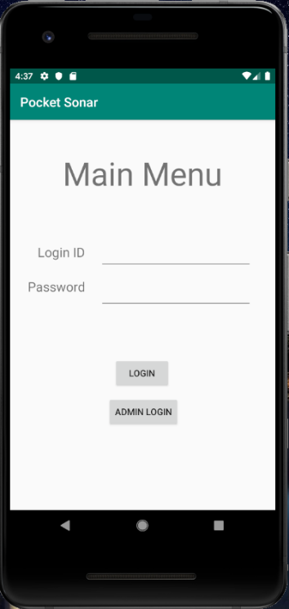

Figure 2.1.1. Main page/User login page

2.2. Menu Options

In addition to admin user, other types of users can be registered as well and depending on the user types, the functions will vary, or some may remain consistent. Attached figures are examples of the functions available to different types of users.

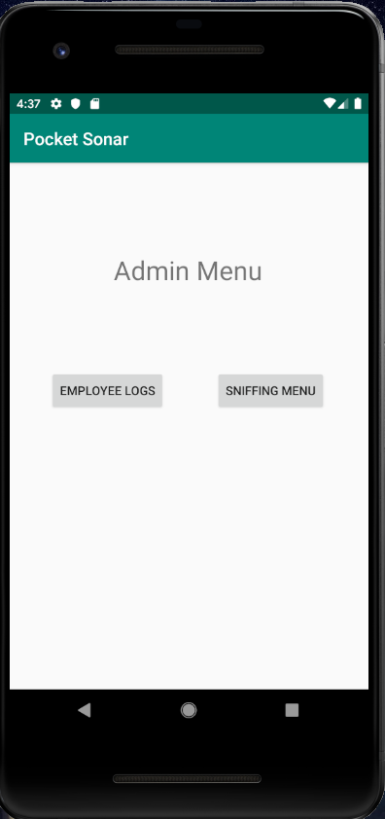

Figure 2.2.1. Admin main page

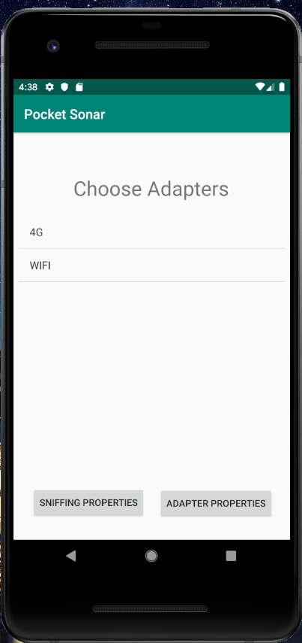

Figure 2.2.2. Adapter selection

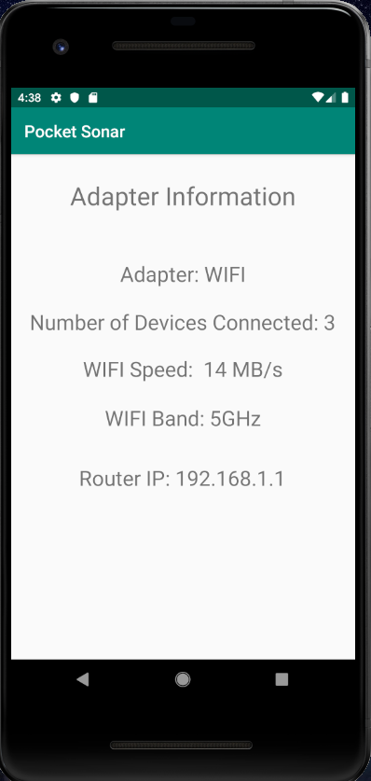

Figure 2.2.3. Adapter information

**2.3. Data collection**

Under data collection page will be the core functions which are to choose the sniffing properties, analyze the network and to display the results. These functions are under implementation as of now and are not functional yet.

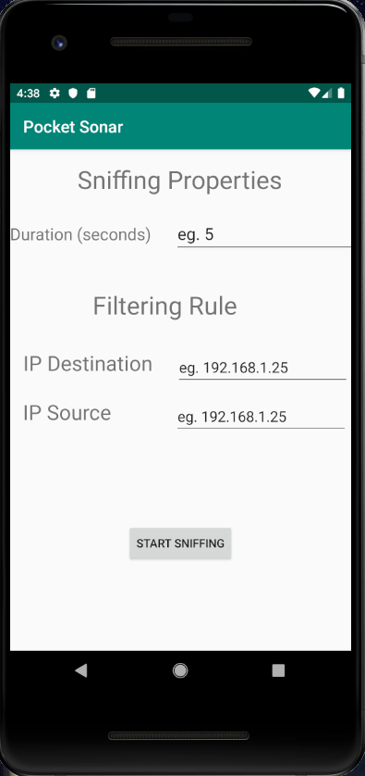

Figure 2.3.1. Sniffing properties selection

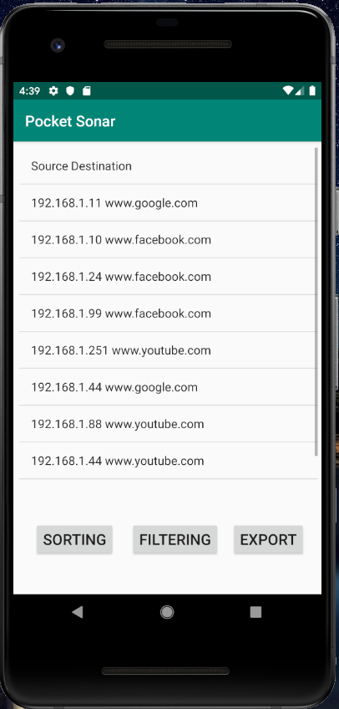

Figure 2.3.2. Sniffing results

1. **Error handling on user side**

If the users encounter any error or problem using our program, they can directly email us or even call us, providing the details of their errors or problems they are facing, and our team will try out best to get back to you with possible solutions as soon as possible.

1. **Team Members Profiles**

|  |  |  |
| --- | --- | --- |
| **Name** | **Phone Number** | **Email Address** |
| NYEIN SOE | 90721870 | nyeinsoe.wayne@gmail.com |
| LIAO WEISHENG WILSON | 97591961 | xalvin.k@gmail.com |
| KAN KAR JUN ALVIN | 98346884 | z.irashi.z@gmail.com |